EQUIPMENT IDENTIFICATION INFORMATION

Lab Name/PI:
Lab/Owner Location:
Building:
Floor:
Room No.:

Power supply to this device

Normal Power Emergency Power

Electrical Power Circuit ID# Voltage

Emergency Contacts

Name: Phone:

Name: Phone:

Name: Phone:

For general inquiries about a PSOM building, please scan below or visit our webpage at

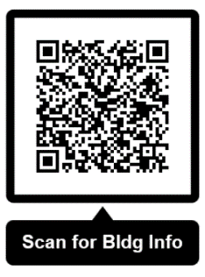
https://www.med.upenn.edu/spo/buildings-and-administrators.html or email PSOMSPO-Ops@lists.upenn.edu

Space Planning & Operations
Operations & Engineering
Perelman School of Medicine
215-898-8760

